CS 145 Project 2 – Inheritance Hierarchies

Objective
The objective of this project is to provide you with practice implementing inheritance hierarchies.

Background
Inheritance allows programmers to be “appropriately lazy” and reuse code in similar classes. We are going to implement an inheritance hierarchy for shapes. As you move down the hierarchy, each class inherits features and code from the classes above it. This will mean that the new code you need to write for each class is kept to a minimum (often no more than a new constructor that calls the superclass’s constructor with a different combination of parameters).

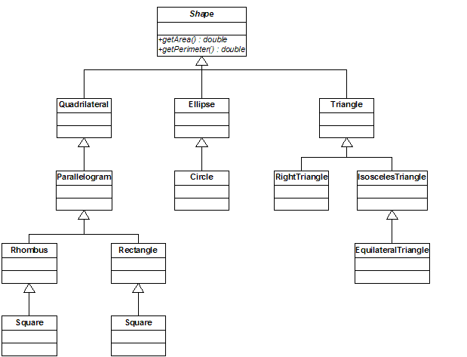

Shape Inheritance Hierarchy
Implement the hierarchy shown on the previous page.

Shape Class
The class Shape is an abstract class. It has two abstract methods:
public double getArea()
public double getPerimeter()

Each of its direct subclasses has its own diagram below.

Quadrilateral Inheritance Hierarchy
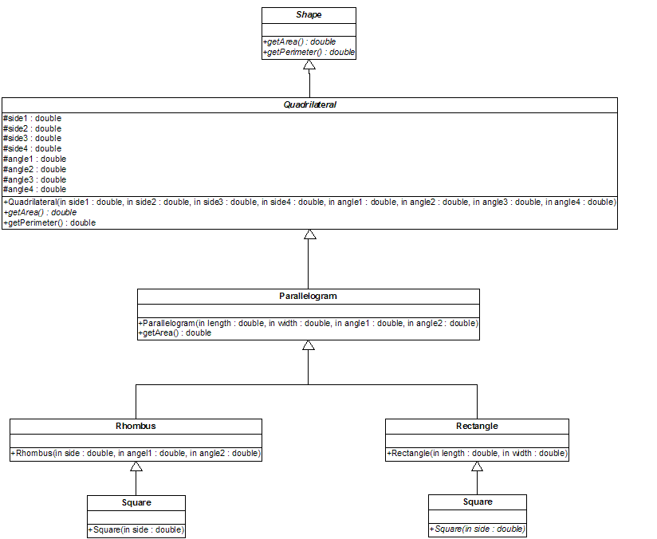

Quadrilateral Class
A Quadrilateral is a 4-sided figure with 4 sides of (possibly) differing lengths, and 4 angles of (possibly) differing measurements.

Quadrilateral is an abstract class because there is no getArea() method.

Quadrilateral has 8 data members:
double side1, side2, side3, side4 - the lengths of the 4 sides
double angle1, angle2, angle3, angle4 - the 4 angles in degrees

Quadrilateral has 2 methods:
Quadrilateral(double side1, double side2, double side3, double side4, double angle1, double angle2, double angle3, double angle4) – a constructor to create the quadrilateral
double getPerimeter() which returns the sum of the lengths of the 4 sides

Parallelogram Class
A Parallelogram is a 4-sided figure with opposite sides of equal lengths and opposite angles of equal measures

Parallelogram has 2 methods:
Parallelogram(double length, double width, double angle1, double angle2) - a constructor that takes the lengths of the sides and the two different angles. The constructor does nothing other than call the constructor of the superclass.
double getArea() - which computes the area which sin(angle1) * length * width

Rhombus Class
A Rhombus is a 4-sided figure with 4 sides of equal length and opposite angles of equal measures.

Rhombus has 1 method:
Rhombus(double side, double angle1, double angle2) - a constructor that takes the length of the sides and the two different angles. The constructor does nothing other than call the
constructor of the superclass.

Rectangle Class
A Rectangle is a 4-sided figure with four 90-degree angles and opposite sides of equal length.

Rectangle has 1 method:
Rectangle(double length, double width) - a constructor that takes the length and width of the sides. The constructor does nothing other than call the constructor of the superclass.

Square Class
A Square is a 4-sided figure with four 90-degree angles and four sides of equal length. You may choose to make Square a subclass of Rhombus OR Rectangle as it has features in common with both. It is your choice.

Square has 1 method:
Square(double side) - a constructor that takes the length of the sides. The constructor does nothing other than call the constructor of the superclass.

Ellipse Inheritance Hierarchy
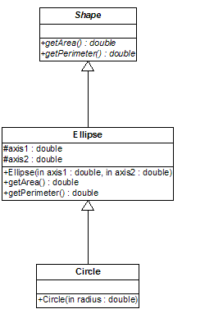

Ellipse Class
An Ellipse is a round figure with two axes of (possibly) differing lengths.

Ellipse has 2 data members:
double axis1, axis2 - the lengths of the two axes.

Ellipse has 3 methods:
Ellipse(double axis1, double axis2) - a constructor to create the Ellipse
double getArea() - calculates the area which is pi*axis1*axis2
double getPerimeter() - calculates the perimeter which is 2*pi*square root( 1/2 * (axis1² +axis2²) )

Circle Class
A Circle is a round figure with a single radius.

Circle has 1 method:
Circle(double radius) - a constructor that takes the radius. The constructor does nothing other than call the constructor of the superclass.

Triangle Inheritance Hierarchy
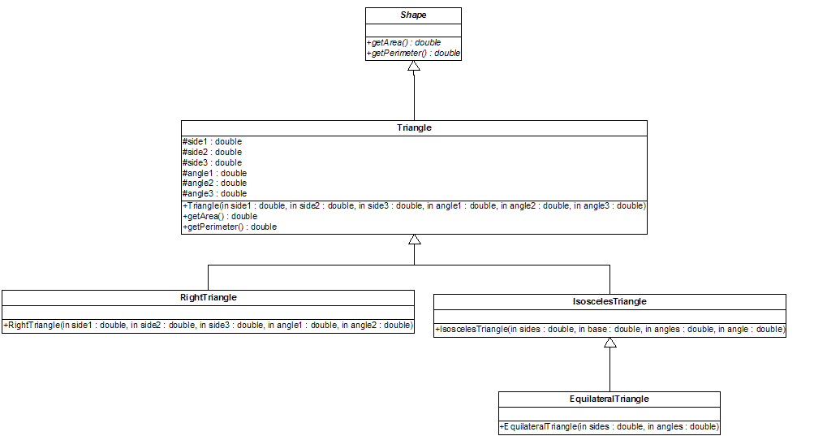

Triangle Class
A Triangle is a 3-sided figure with three sides of (possibly) differing lengths and three angles of (possibly) differing measurements.

Triangle has 6 data members:
double side1, side2, side3 - the lengths of the three sides.
double angle1, angle2, angle3 - the measurements of the three angles

Triangle has 3 methods:
Triangle(double side1, double side2, double side3, double angle1, double angle2, double angle3) - a constructor to create the Triangle
double getArea() - calculates the area which is sin(angle1) * side1 * side3 * 1/2 (where side1 and side3 are the sides on either side of angle1)
double getPerimeter – calculates the perimeter which is the sum of the lengths of the sides

RightTriangle Class
A RightTriangle is a 3-sided figure with three sides of (possibly) differing lengths, one 90 degree angle and two angles of (possibly) differing measurements.

RightTriangle has 1 method:
RightTriangle(double side1, double side2, double side3, double angle1, double angle2) - a constructor to create the Triangle. The constructor does nothing other than call the constructor of the superclass.

IsoscelesTriangle Class
An IsoscelesTriangle is a 3-sided figure with two sides of the same length and one side of (possibly) differing length , two angles of the same measurement and one angle of (possibly) differing measurement.

RightTriangle has 1 method:
RightTriangle(double sides, double base, double angles, double angle) - a constructor to create the Triangle where sides is the length of the two equal sides and base is the third side, angles is the measurement of the two equal angles and angle is the measurement of the third angle. The constructor does nothing other than call the constructor of the superclass.

EquilateralTriangle Class
An EquilateralTriangle is a 3-sided figure with three sides of the same length and three angles of the same measurement.

EquilateralTriangle has 1 method:
EquilateralTriangle(double sides, double angles) - a constructor to create the EquilateralTriangle. The constructor does nothing other than call the constructor of the superclass.

Test Code and Output
I have provided a test class for you to use, and here is the output of that test class to compare to your output:

class Parallelogram area = 4.242640687119285 perimeter = 10.0
class Rectangle area = 6.0 perimeter = 10.0
class Rhombus area = 2.82842712474619 perimeter = 8.0
class Square area = 4.0 perimeter = 8.0
class Ellipse area = 18.84955592153876 perimeter = 16.01904224441409
class Circle area = 12.566370614359172 perimeter = 12.566370614359172
class Triangle area = 0.35355339059327373 perimeter = 3.0
class RightTriangle area = 4.0 perimeter = 9.0
class IsoscelesTriangle area = 2.1213203435596424 perimeter = 7.0
class EquilateralTriangle area = 1.7320508075688772 perimeter = 6.0

Note about Angles
The Math.sin() method expects angles in radians rather than degrees! Fortunately, there is a Math.toRadians() method that you can use. So, wherever you want to use a 90 degree angle, you should use Math.toRadians(90.0) instead. The test code reflects this change, but you should be sure that you do this wherever you use 90 degrees in constructors in your own code.

Deliverables
Send me an e-mail message, attached to which is a single archive file that contains all 12 of your Java source files. Do not attach all 12 files to an e-mail message. An example of an archive file would be a compressed folder, a zip file, a tar/gzip file, a tar/bzip file. I can extract files from most archive formats (I use 7-zip).
You must follow the style guidelines regarding javadoc and Java coding conventions. If you do not know what these are, then it means I will be presenting them to you very soon. I will be taking points off for major deviations from the guidelines.

Due Date and Time
Before midnight on Friday, September 25, 2009. This time I have the right year. ;)

